**AIM:** **Analyze the packets provided in lab and solve the questions using Wireshark :**

- What web server software is used by [www.snopes.com](http://www.snopes.com)?

- About what cell phone problem is the client concerned?

- According to Zillow, what instrument will Ryan learn to play?

- How many web servers are running Apache?

- What hosts (IP addresses) think that jokes are more entertaining when they are explained?

**What webserver is this website using?**

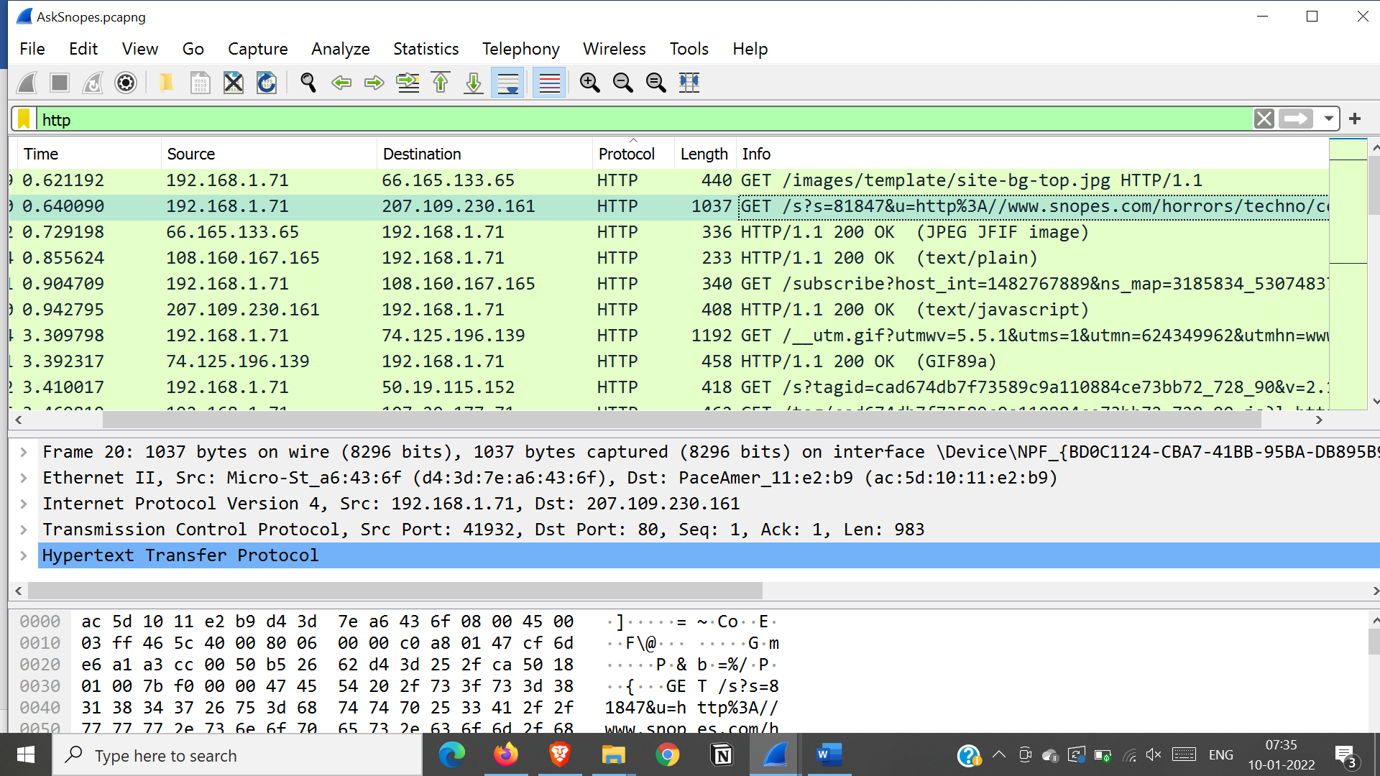

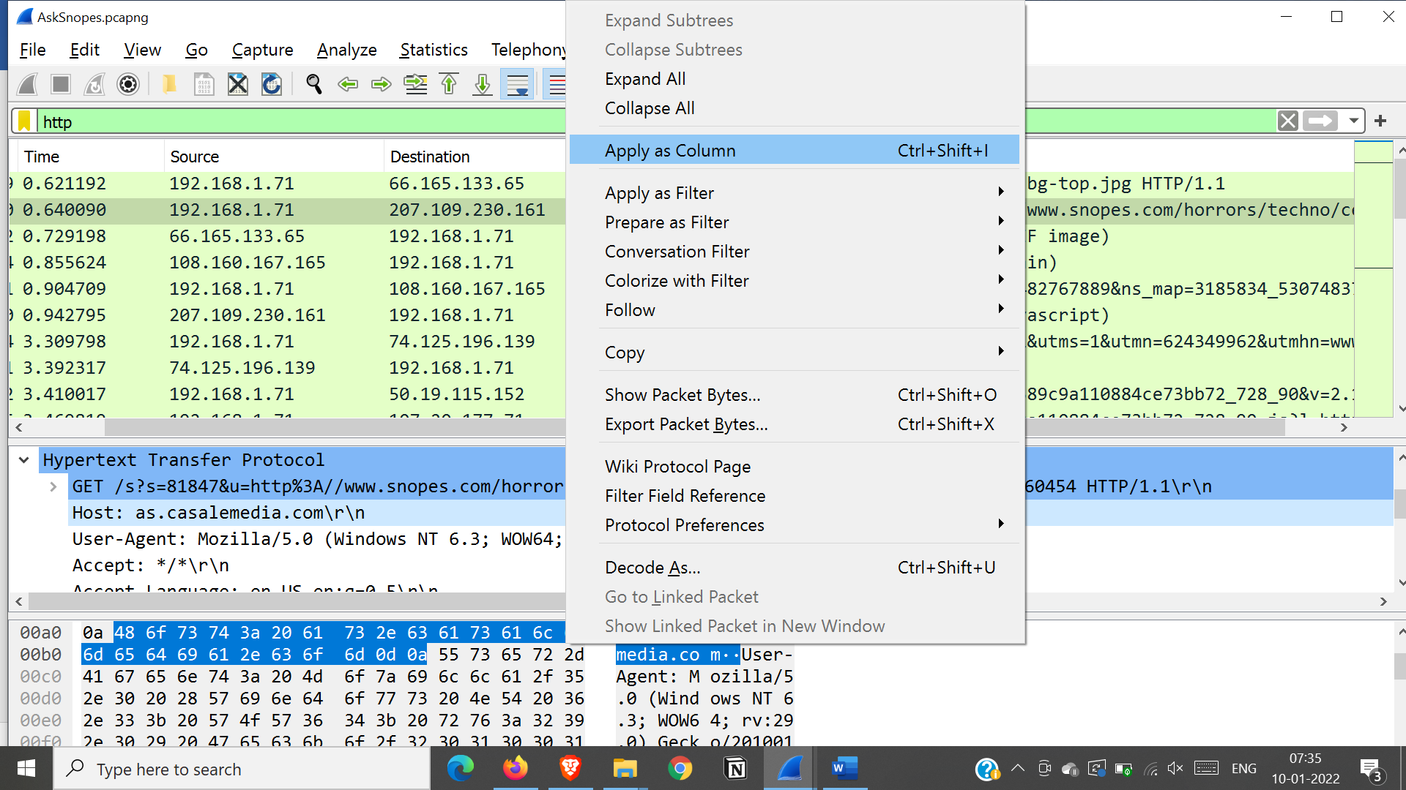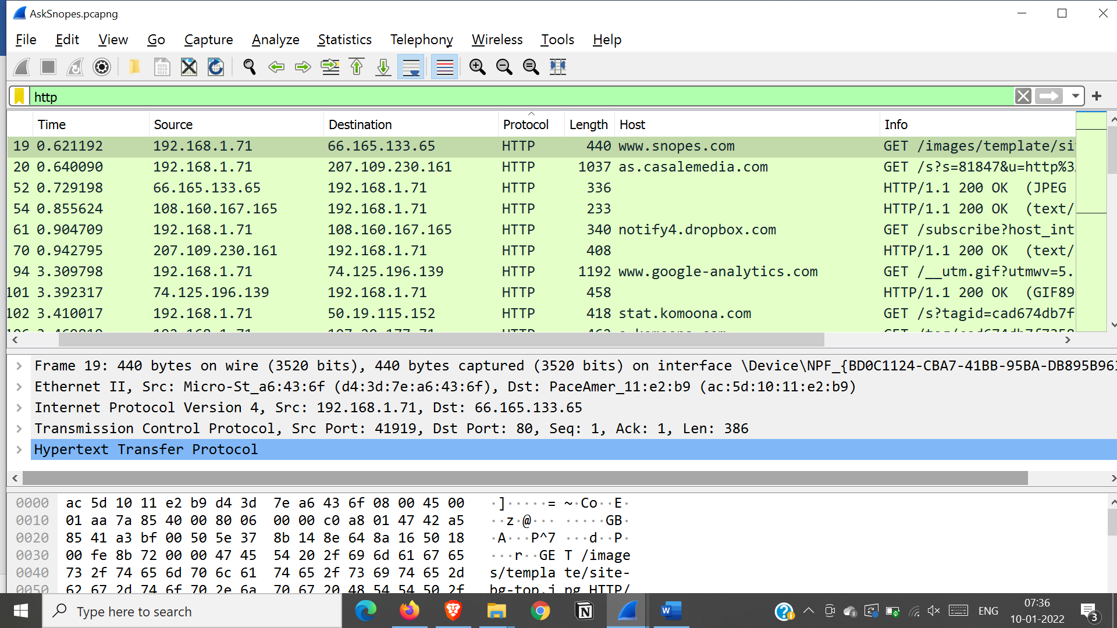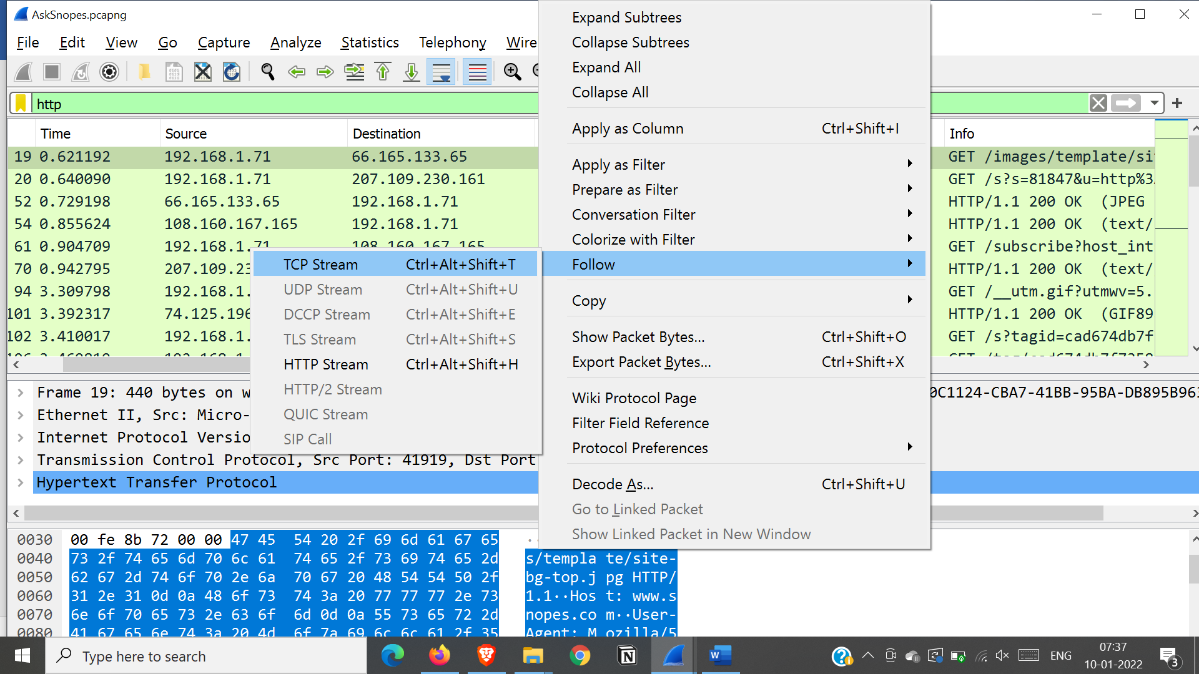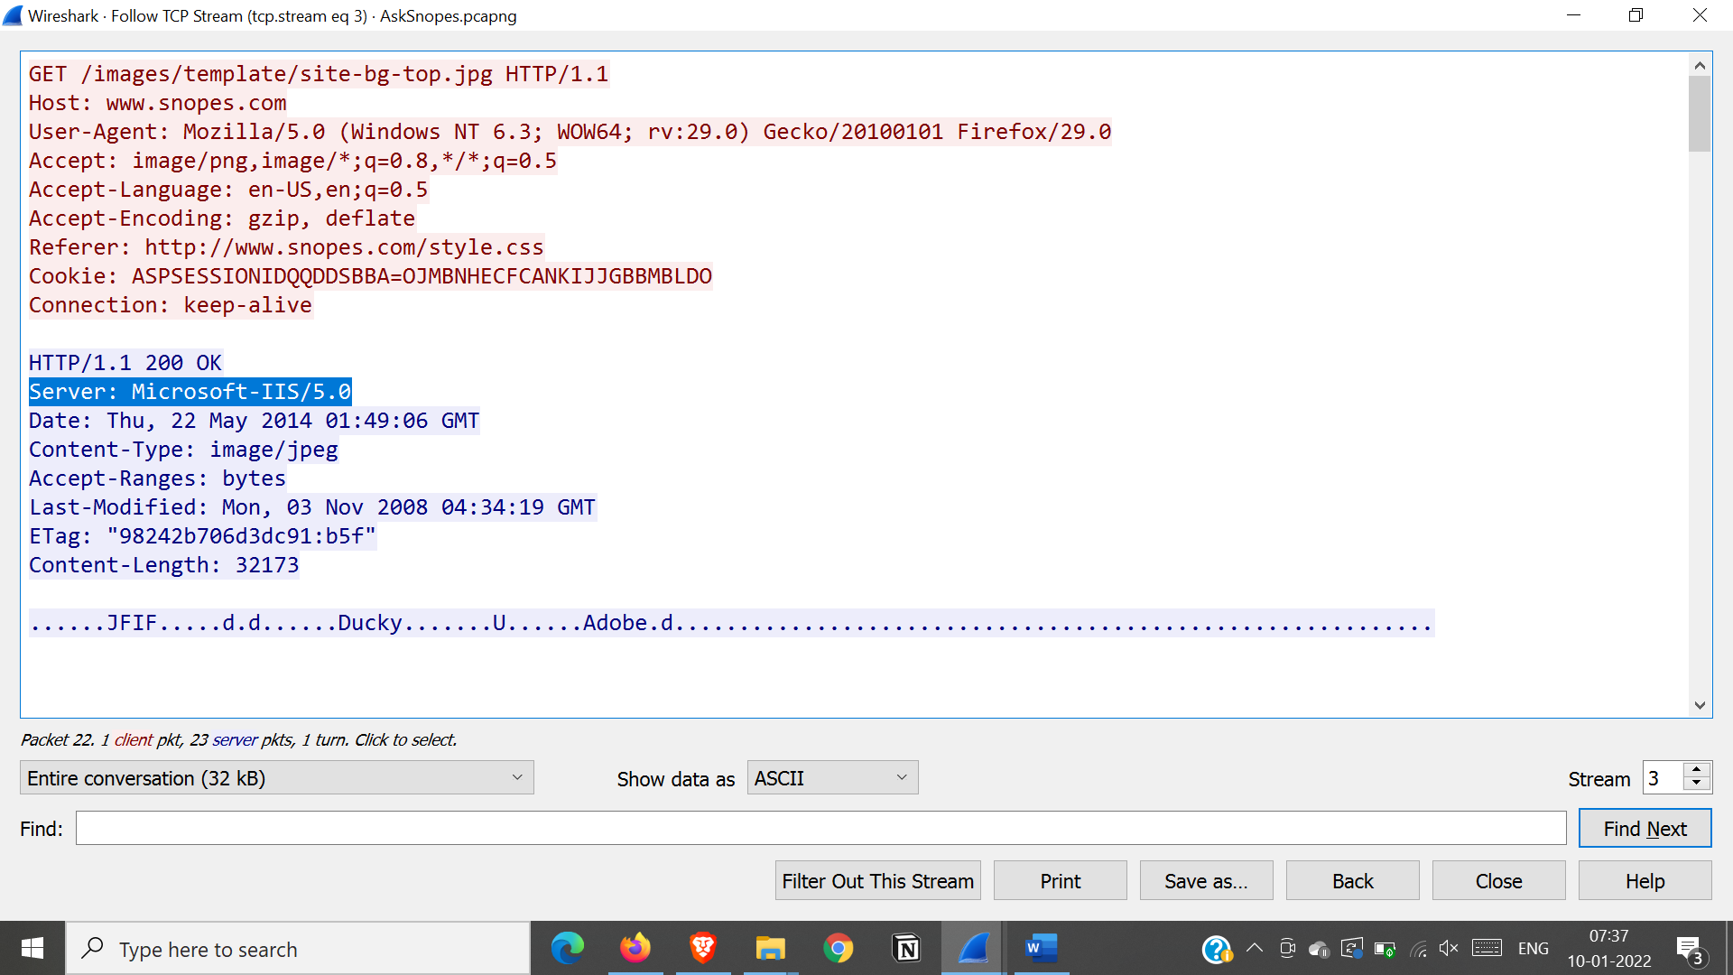

Server is Microsoft iis server

**About what cell phone problem is the client concerned with?**

Search for a keyword cell in all cell packets using regex

frame matches ”(?)cell”

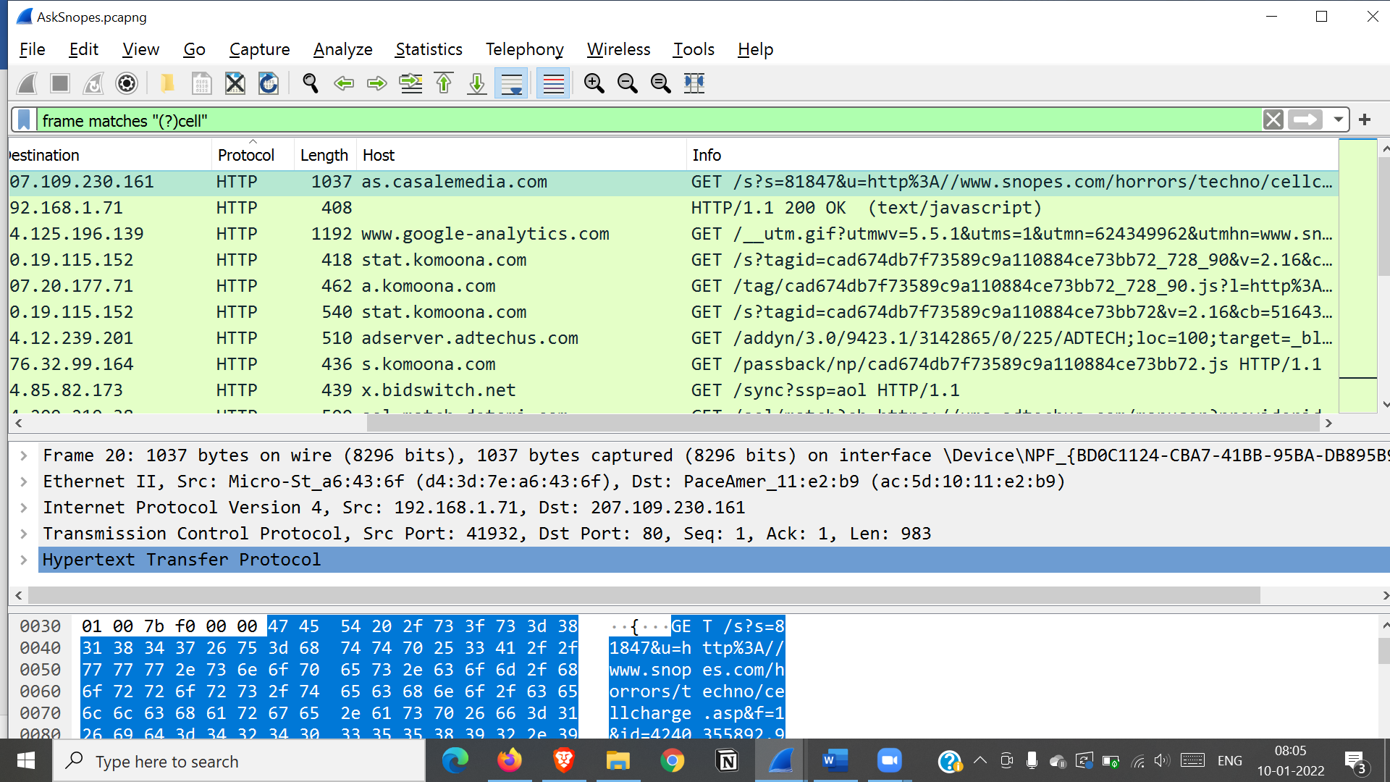 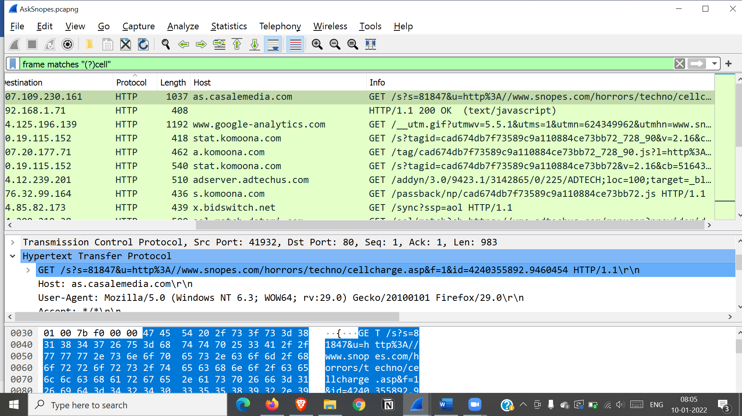

Client had searched for cell charge problem

**How many webservers?**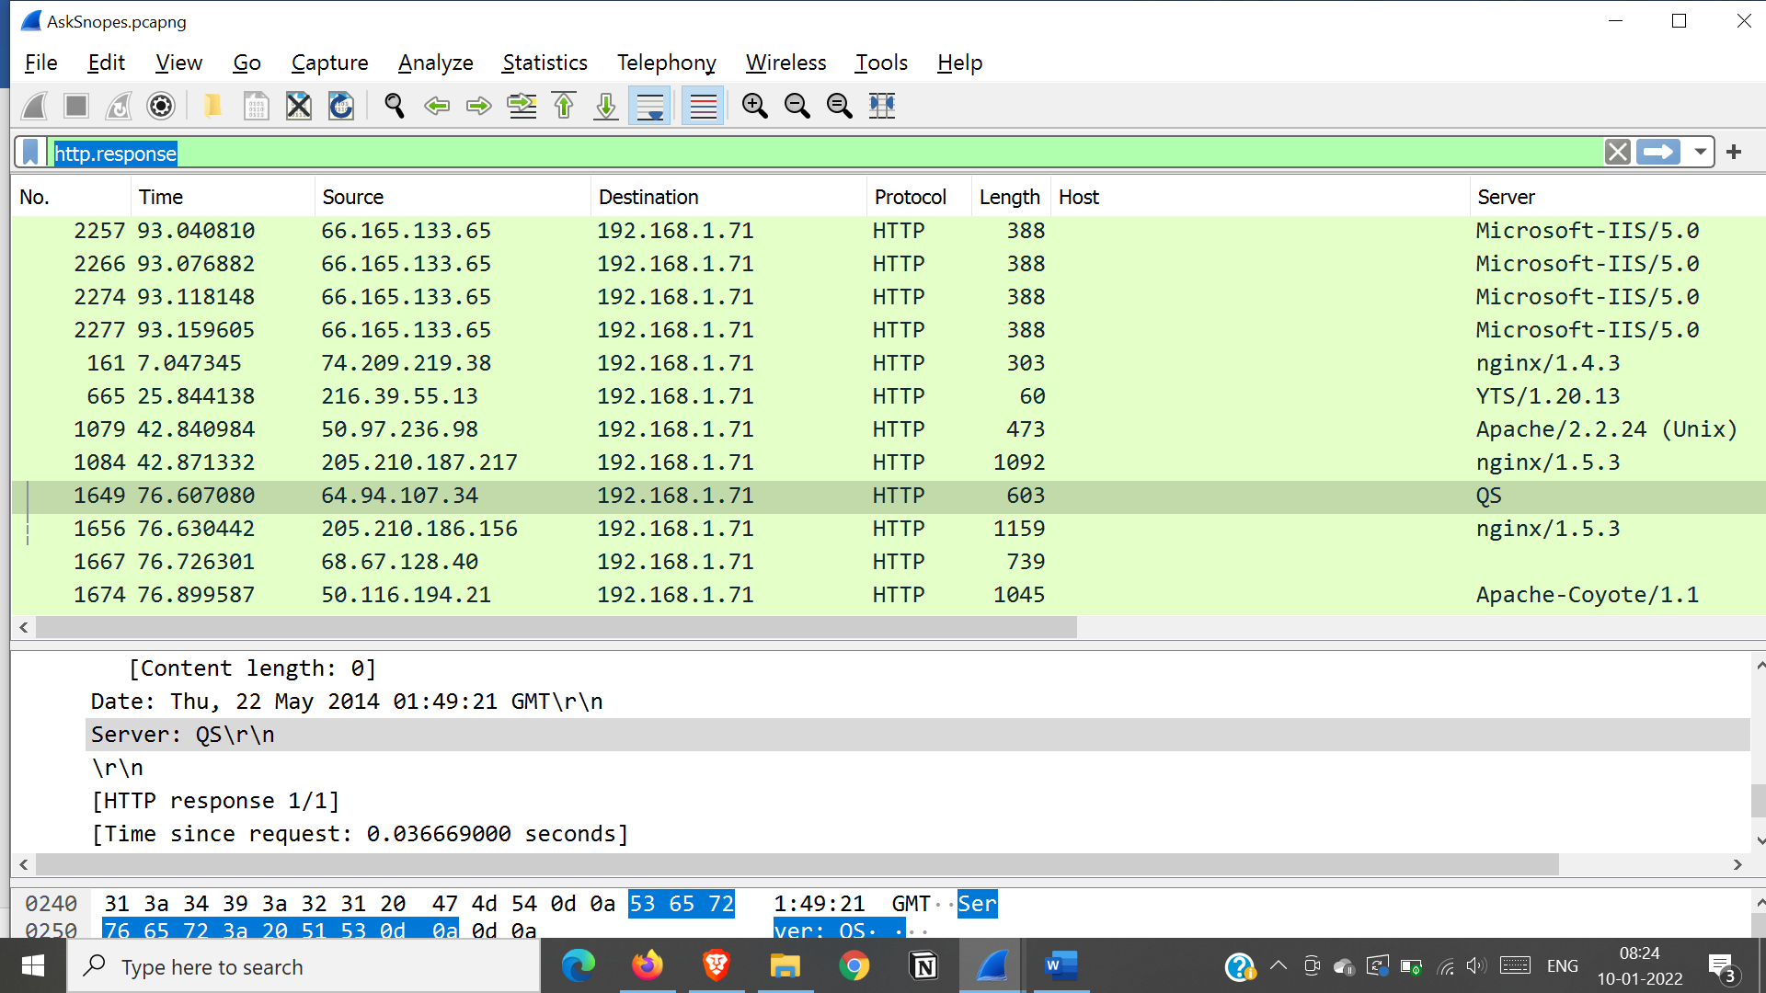 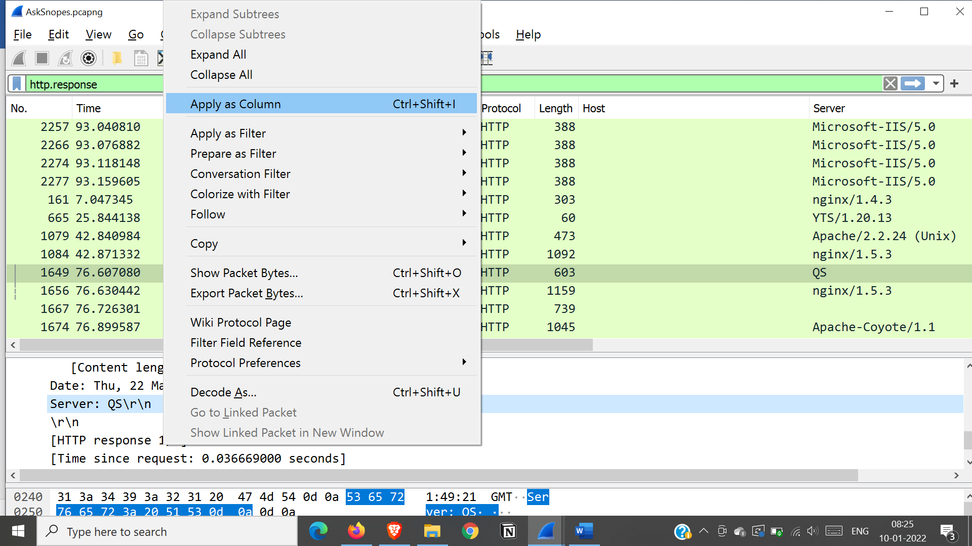 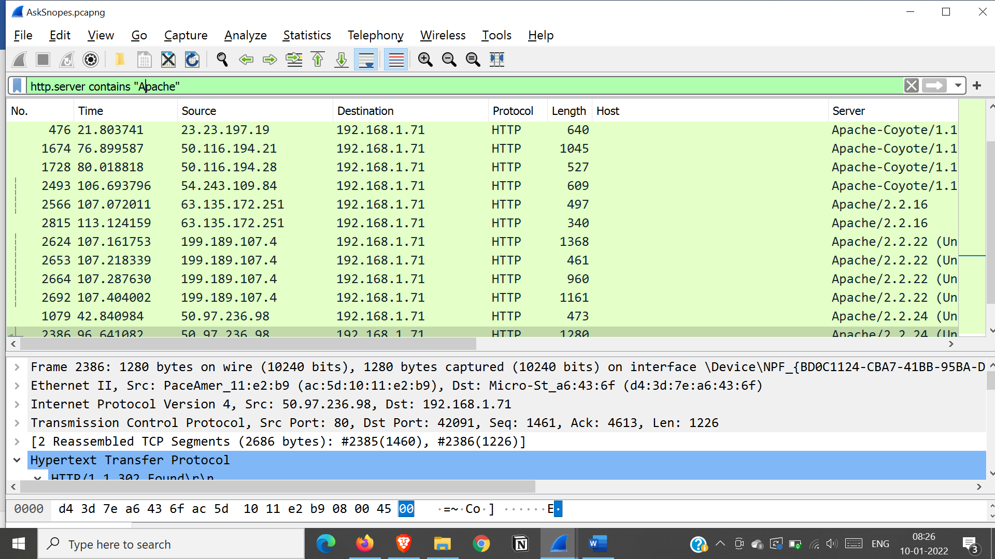

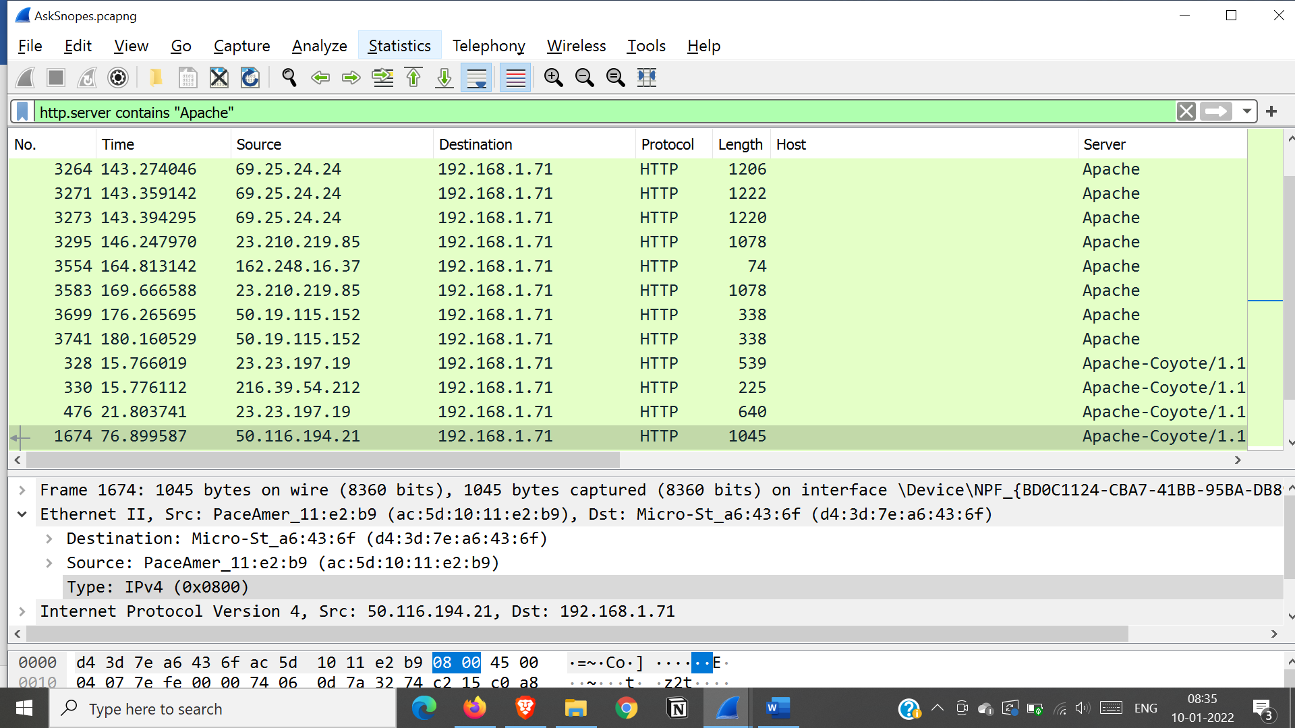 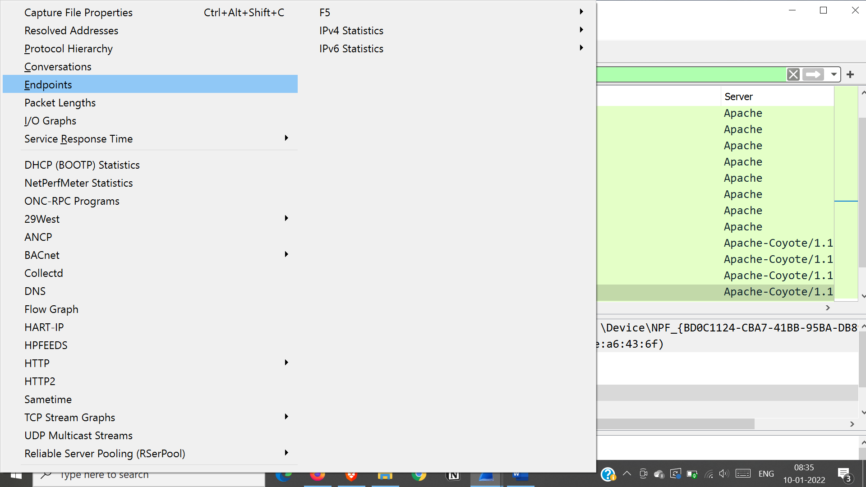 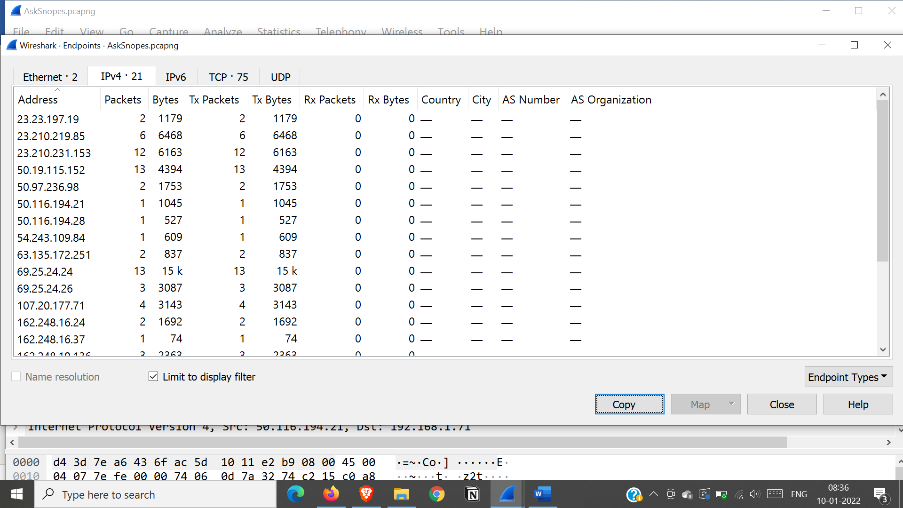

**What hosts think Jokes are more entertaining when they are explained?**

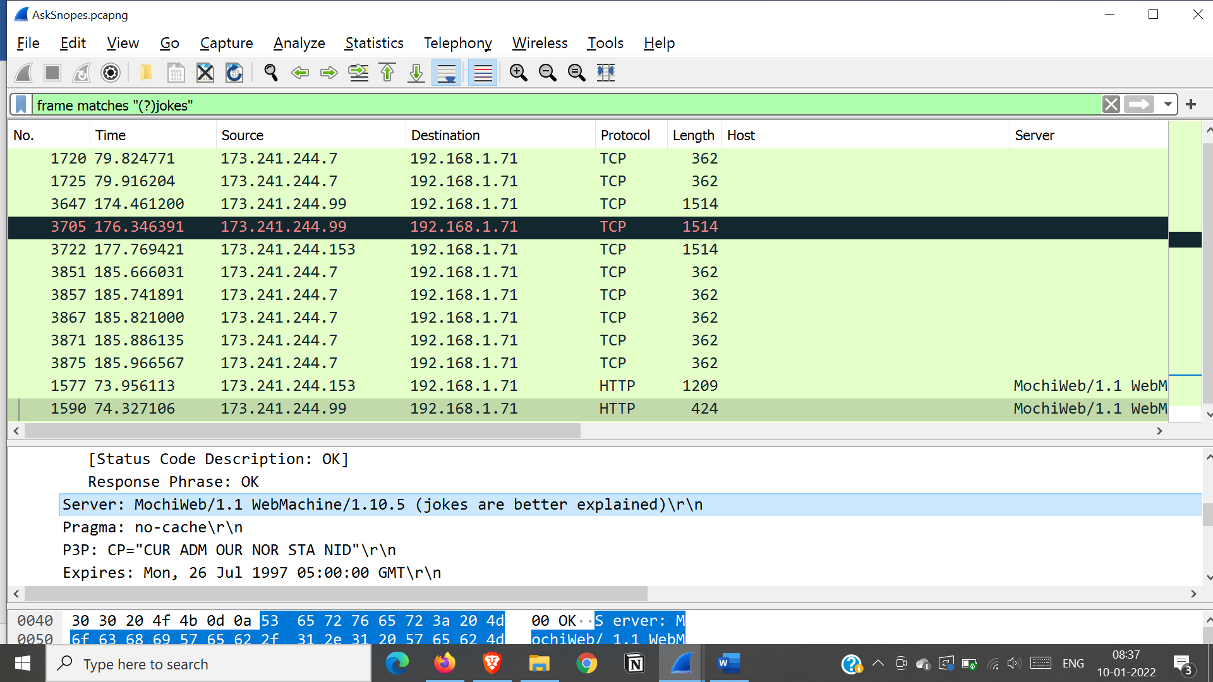

**According to Zillow what instrument will reyan learn to play?**

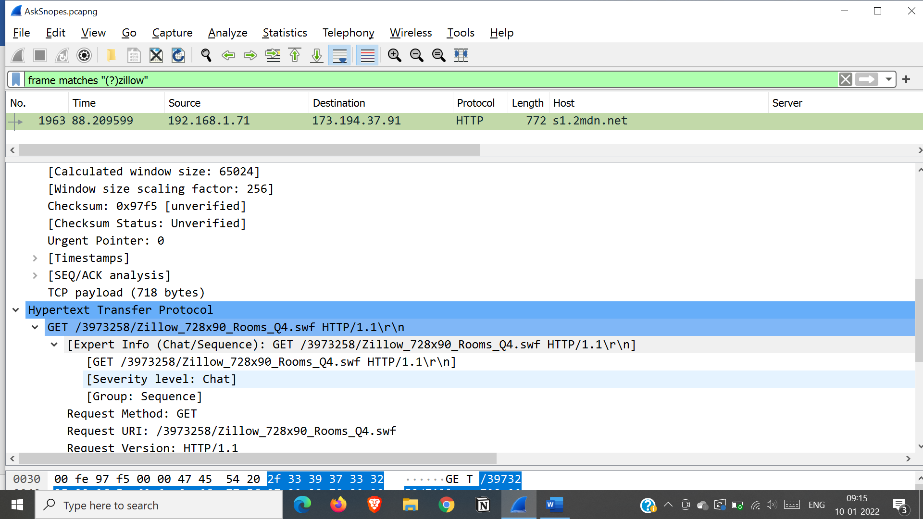 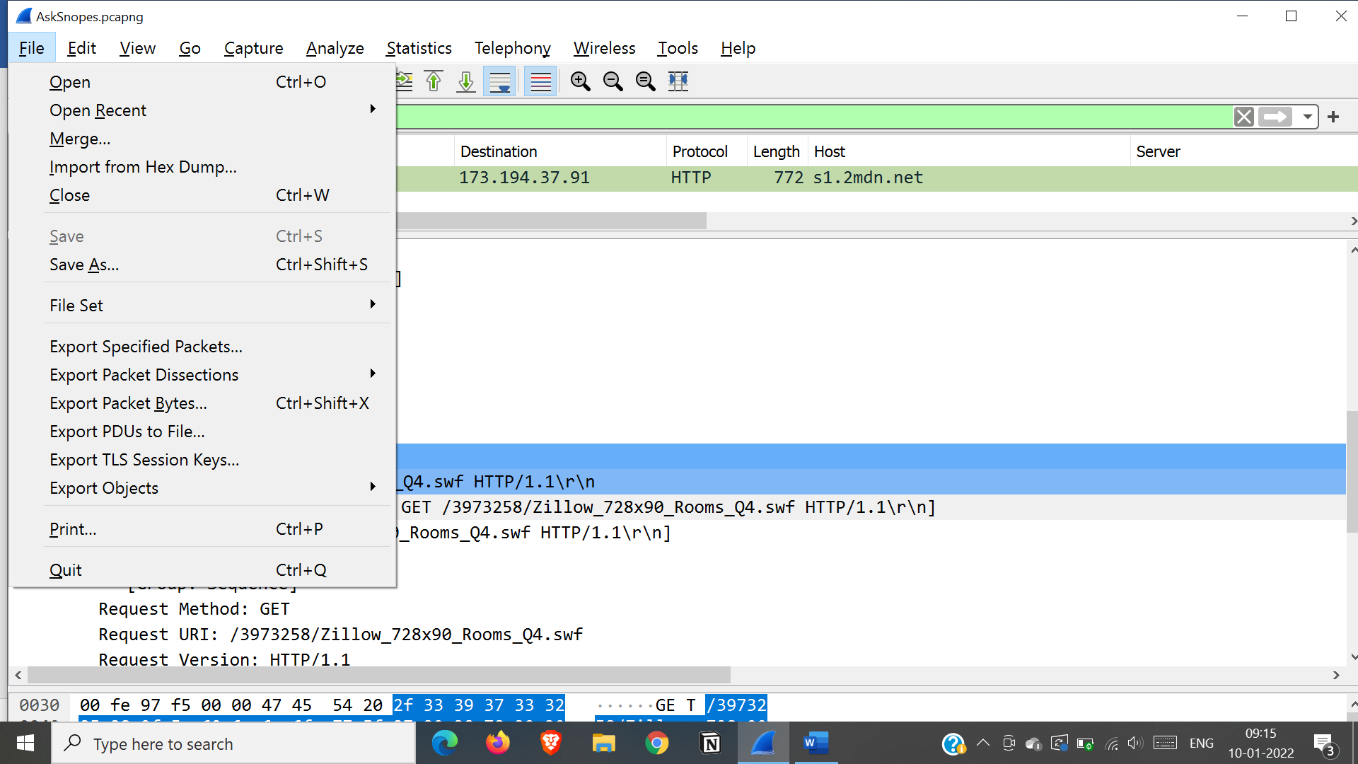 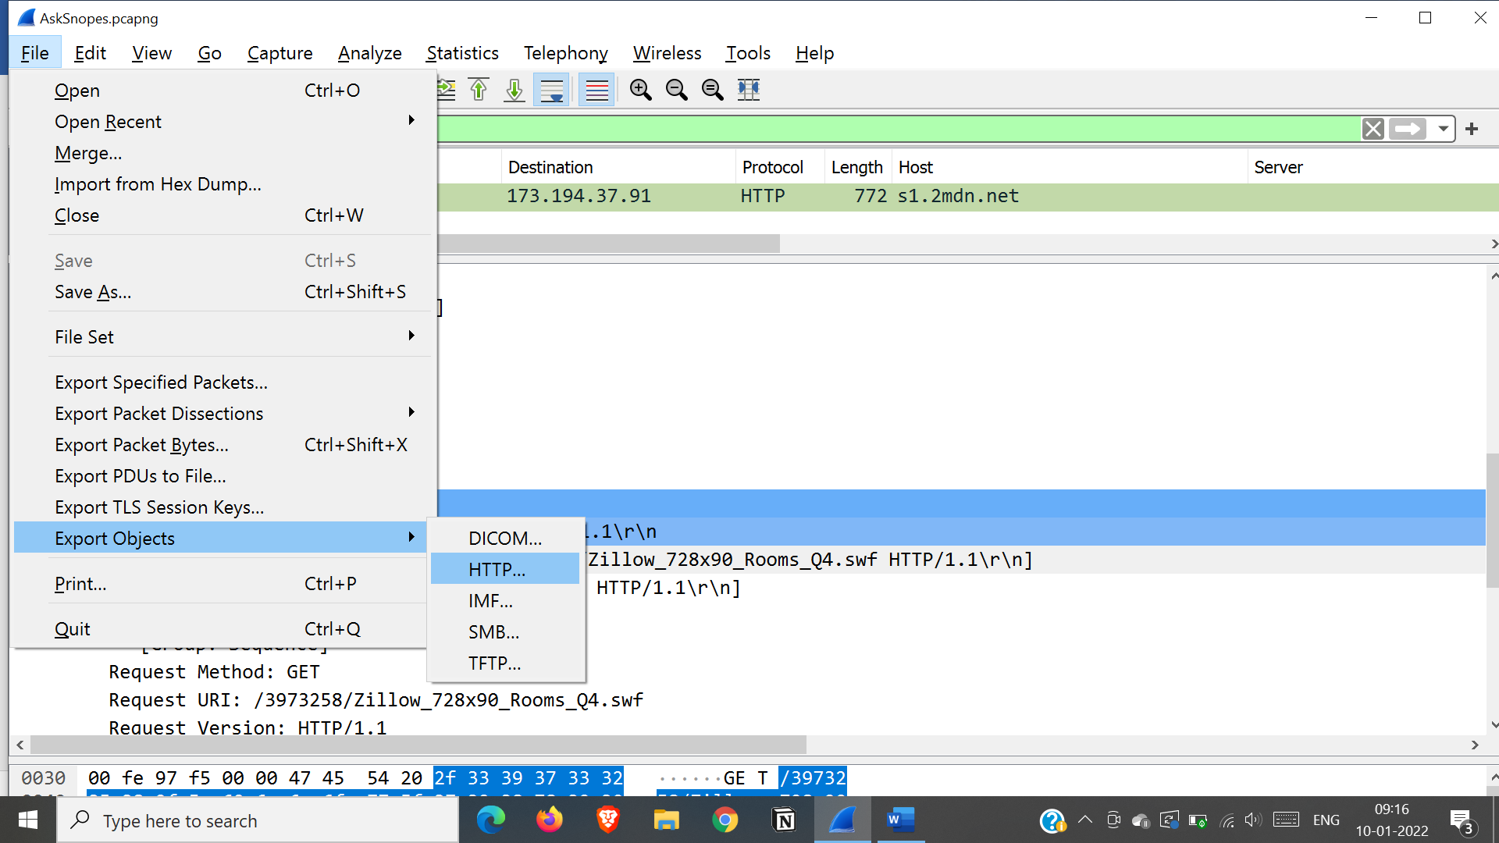 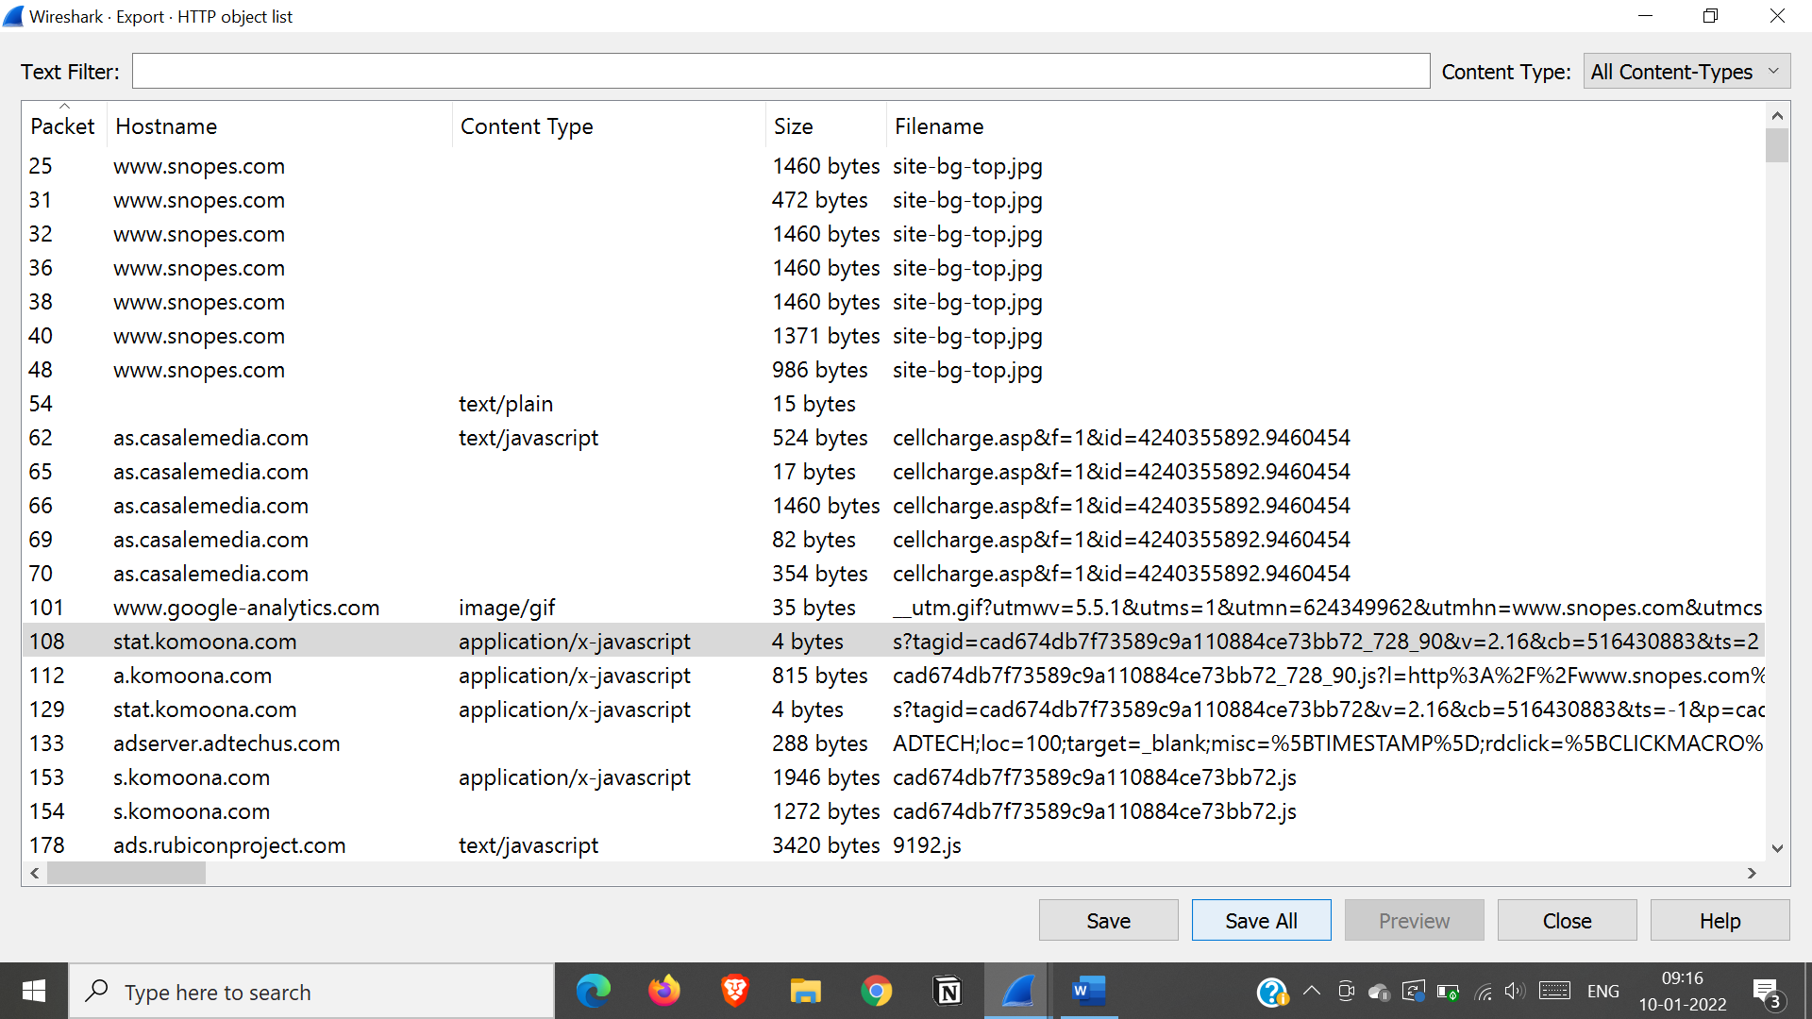 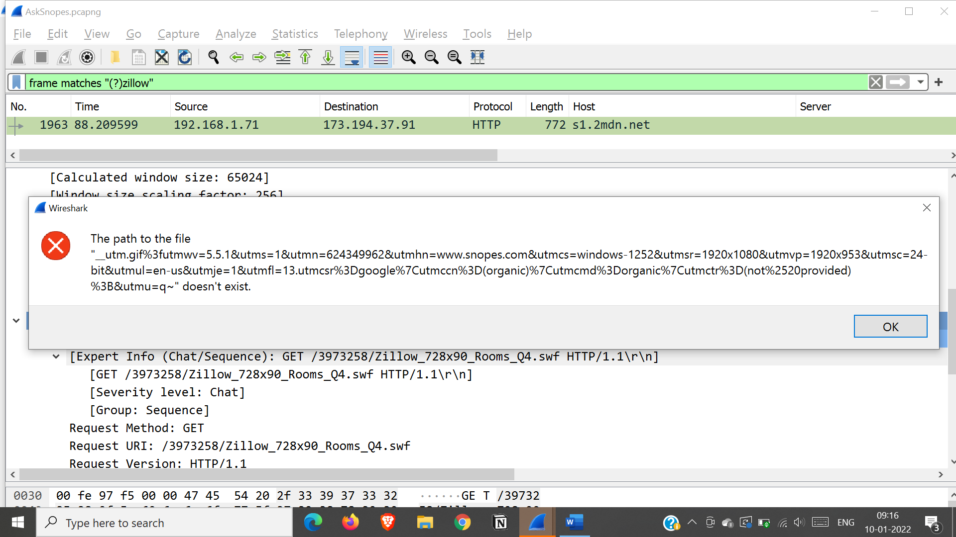

Mark ok to all errors

Open zillow.swf file from extracted paths

